School of Computing, Creative Technologies, and Engineering 2021/22
Level 6 Production Project
MEETING RECORD SHEET: |  |  | Meeting  Number: 1
Student: Anupam Siwakoti |  | Student I.D.: C7227267
Date of Meeting: Feb 25, 2022 |  | Supervisor: Resham Bdr Pun
Actions agreed at previous meeting (completed or comment):
1 | Completion of initial project plan ◻
2 | ◻
3 | ◻
4 | ◻
5 | ◻
6 | ◻
Comments of student (if any):
This was the first meeting with our supervisor, I discussed with him about the topic, Software Development with DDD and related architectures. He agreed upon this title and the doorway for my further research.
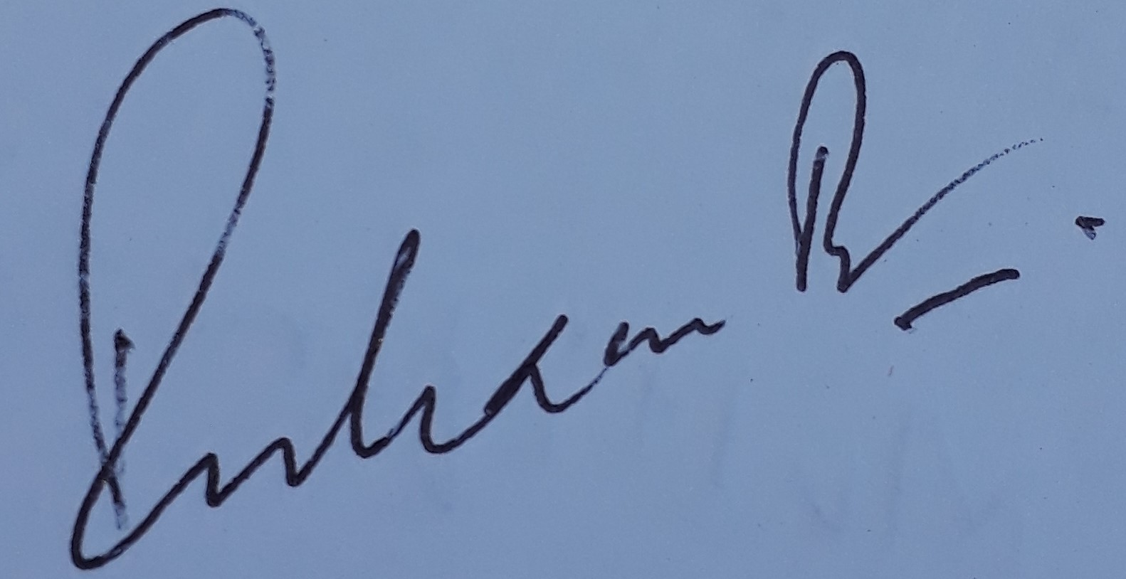
ABOVE here – student to complete before Meeting with supervisor. BELOW here – complete at the Meeting.
Next meeting (date/time): March 2nd, 2022
Agreed Actions to complete before next meeting:
1 | Start to read books, blogs, and articles on DDD
2 | Start writing the literature review
3 | Think about the prototype
4
5
6
Comments of supervisor (if any):
I accepted the topic of the student, now he will start his research on the suggested topic.

